**BG-Watch**

**Team member: 1. Dina Magdy youakem**

**2. Mariam Malak Fayez**

**Sechan number: 1**

**Project number: 97**

**Patrician: Software**

|  |
| --- |
| * **OVERVIEW:** * **Benefits:**   **The company will develop a software for this BG watch.**  **We’ll add an operating system with great performance to enhance the connection between the watch and the person.**  **The watch works only with Android system.**   * **Deliverables:**   First, collecting different data from blind people about their problems in moving in streets and using mobile phones with GPS.  Second, analyzing this data to define the main problem and choose the suitable software design to create.  Third, designing a software with voiceover feature to help them in moving anywhere with voiceover GPS and know any other things with google assistant voice.  Fourth, testing voiceover feature after designing it in software and the whole software after ending.   * **Scope(In/Out):**   (In): Designing a software with new features to match the need and assistance of the blind.  BG watch finds a solution for blind people problems.  This software only for modern android systems.  (Out): This software will not work with IOS systems and old android systems.   * **Milestones:**   Collecting data completes by June 2022.  Analyzing data completes by the end of 2022.  Designing software completes by 2024.  Testing complete and finished by 2025.   * **Technical requirement:**   The system will be written in Java because our organization wants to take orders for its products and services on the Internet.  So our engineers will write that component in Java that can be accessed via the Internet.  Smart watches give people lightweight and immediate access to messages  notification, and other digital data while on the go.  While already powerful as standalone devices, the capabilities of  smart watches increase significantly when used in tandem with other  devices that people carry, such as their phones or tablets, which allows for  novel cross device interaction techniques.   * **Problem:** * Some people - who are blind - have a problem at moving out- side   and recognizing the way, they only hear sounds around them and  don’t know the source of it.   * The blind people may lose their phones or forget them at home   so they won’t be able to move at streets and recognize any other place.  The mobile is an obstacle to them in moving and carrying other  things, and it’s possible to fall without realizing and they can’t find it.   * **Solution:** * We design BG watch to help blind people by telling   google assistant the place they want to go to and with voice over  facility, BG watch will guide them to the right destination and choose  safe route with less obstacles.   * With voice over facility in the watch, google assistant will   inform them all details about every notification they get.   * **Main Objectives:** * As a result of researches, the company decides to develop a smart watch that   automatically describe the road for blind people and tell them everything about  their world.  The project should be completed within 5 years at a cost not to exceed 3 million $   * **Objectives:**   Selling BG watches will increase the rate of sales of the company.  Buying BG watches may increase the capital of the company  so workers’ salaries may increase.  Creating BG watches will increase workers’ knowledge and experience |

* **Limits and exclusions:**

Work is allowed only between the hours of 8:00 pm - 5:00 am at offices or home; System maintenance and repair will be done only up to one month after final inspection; The company will create its system and software not its hardware.

* **Recourses:**

The resources needed to develop the watch:

Engineers and workers to develop its software (not exceed 5 persons).

Courses for workers to develop its software efficiently.

* **Risks:**

Its new software can’t connect to the phone, so the blind can’t control the watch:

* Enhance the connection with Bluetooth and Wi-Fi so if Wi-Fi connection lost, the connection with Bluetooth will work.

Get bad manufactured hardware from factories.

Lose its charge very quickly, so it won’t connect for a long time

Get lost in your personal data or be easily hacked:

* Create strong algorithms to prevent hacking or lost in data.
* **Way of communication:**

Company’s teams will get communicated face-to-face or by online meetings.

The manager will get communicated with factories by e-mails, and with his team face-to-face.

The team leader will communicate with clients by e-mails, calls and online meetings.

* **WPS:**

F

G L M N O E

K H

A B D C

* **PBS:**
* 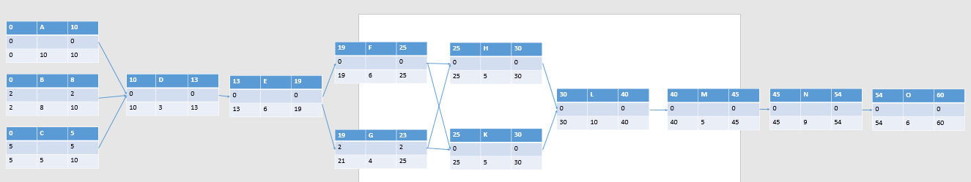**Network:**
* 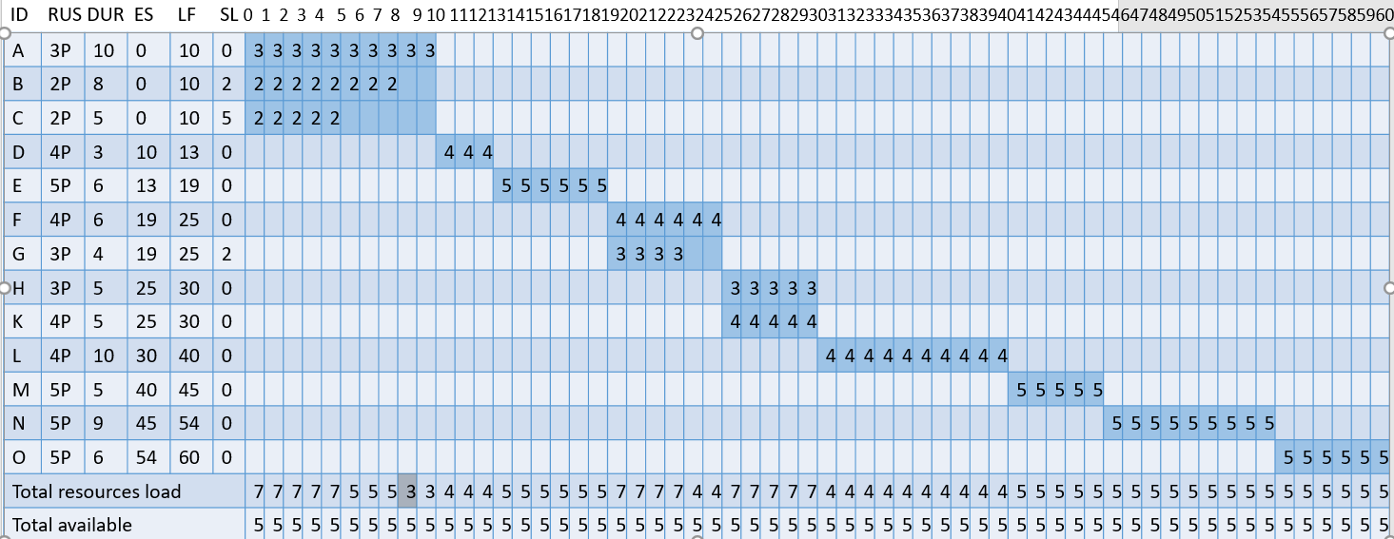**Resources:**
* 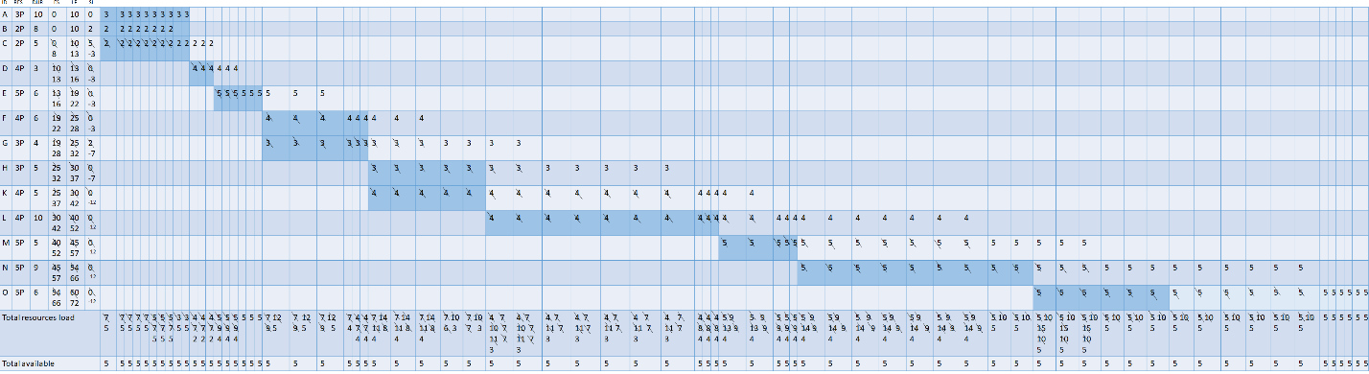**Resources after shifting:**
* 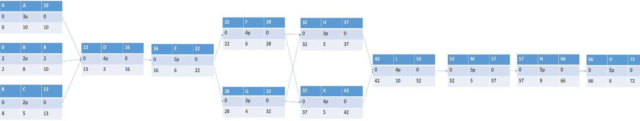**Network with shifting:**
* 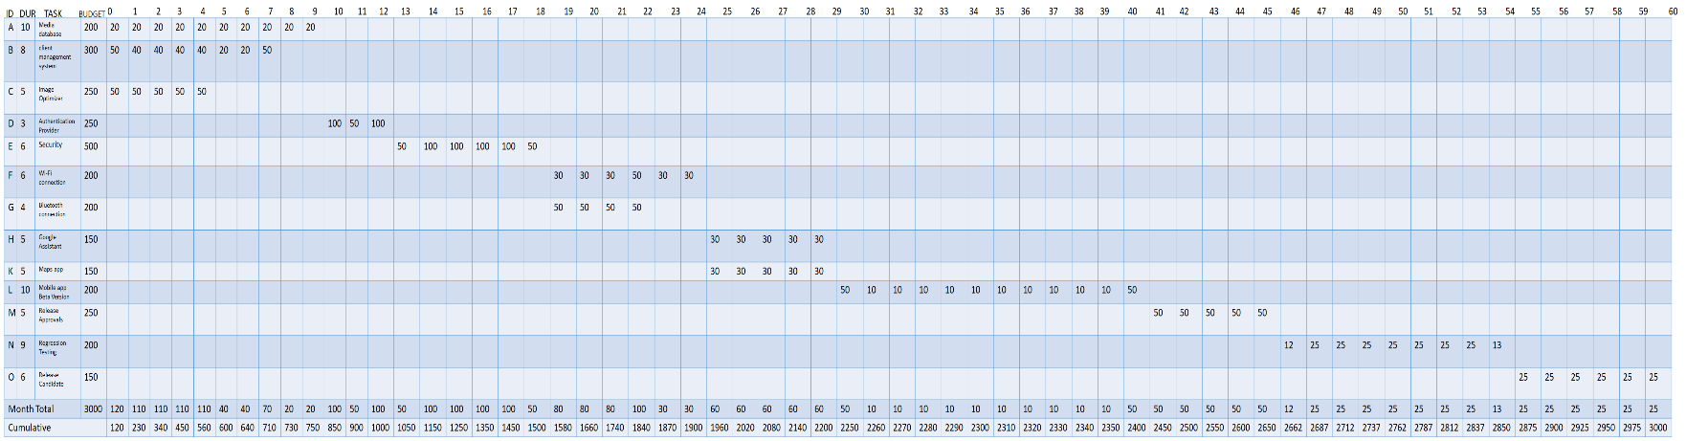**Time – phase Budget (000$):**

Cumulative

Baseline

Budget

(PV)

* **Team members:**

**S = responsible.**

**A = assistant.**

